Model Predictive Control – The Project

Introduction
In this project I’ll implement Model Predictive Control to drive a vehicle around the race track in simulator. Project has challenge as there is 100ms delay to send commands to simulator so there need to be a way to handle latency in order to drive car safely on road.

Vehicle State
Vehicle state is presented by a position, orientation and speed and from these we’ll get following state vector.

Where
x = horizontal position
y = vertical position
ψ= orientation (psi, yaw, heading)
v = speed (absolute velocity)

Control inputs can be presented by steering angle and combined value for throttle and brake. Positive throttle values are accelerating vehicle and negative values are decelerating vehicle.

Where

δ = steering angle
a = acceleration

By combining state and controls we’ll get full state vector which presents vehicle’s state.

Bicycle Kinematic Model
In this project I’m using bit simplified version bicycle model which is quite enough for car speed below 50mph in simulator. If purpose is to go faster with this simplified model then you can play with latency and look-ahead time which are used compensate lag.
I’m using two different models to predict car’s position in future. Linear and CTRV model. Linear model is assuming that vehicle is travelling straight line and CTRV model takes into account vehicle’s yaw rate.

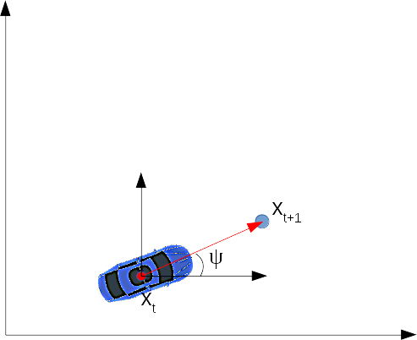Illustration 1: Linear Model
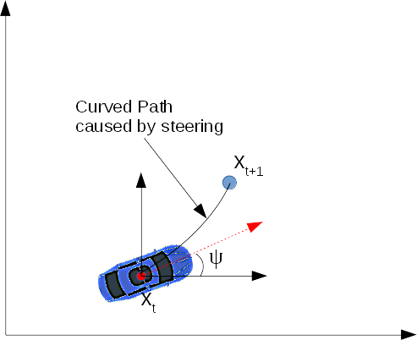Illustration 2: CTRV Model
When vehicle’s yaw-rate is close to zero vehicle’s position in future can be calculated by using linear model. See following equations.
Illustration 3: Linear Model

Where
t+1 = future state
Lf = distance from front axle to center of gravity

If vehicle’s yaw-rate is high then linear model can’t predict car’s state accurately and we should use CTRV model. Problem here is that in order to use CTRV model efficiently we need to know vehicle’s yaw-rate. Again problem.. Yaw-rate is not presented by the model, but we can use steering angle to roughly estimate yaw-rate. Estimations are mostly good enough on low speeds.

Illustration 4: CTRV Model

Improvements
By adding yaw-rate into model we can achieve more accurate results because then we also got information about the actual yaw-rate and we are not limited by estimating it from steering angle. After implementing yaw-rate into model our state vector looks like this:

Illustration 5: Vehicle state vector with yaw-rate

Problem here is that simulator doesn’t return yaw-rate. Fortunately it’s possible to calculate yaw-rate from the measurements and correct it with prediction calculated from steering angle. For simplicity we assume that acceleration is 0.

Old Stuff

Estimating vehicle XY-position when yaw-rate is zero

Estimating vehicle orientation (psi), below equation is approximation which works for small steering angles.

This one is the more accurate model which gives better accuracy when steering angle is high.

